48 Port 1U Rackmount CAT5E UTP Patch Panel (PPAN-48-LC-1U)
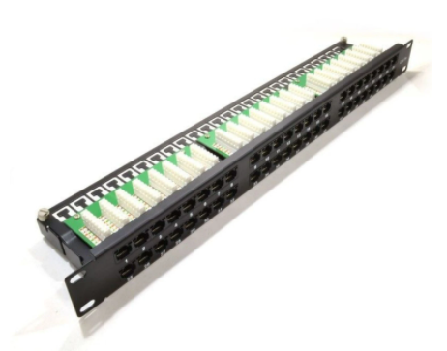

Description:
The LMS Data PPAN-48-LC-1U is 48 Port certified high-density CAT5e UTP Patch Panel which is ideal for structured cabling installations in offices of all sizes. Using two rows of 24 Ports means its an ideal solution for high density cabling installations and reduces costs when compared to buying separate 24 Port Cat5e Patch Panels.

Fully Gigabit Ethernet certified means its ideal for running legacy and advanced networking protocols to Gigabit Switches up up to 1000Mbps. Also ideal for telecom, VoIP, CCTV-IP and other Ethernet based standards.

Long-life, nickel plated female RJ45s, robust construction with colour-coded rear Krone(tm) KATT type IDC for both TIA-568A/B terminations.

Looking for high-density patching for your data or telco network, but are restricted on vertical space within your enclosure? The PPAN-48-LC-1U is a fully metal designed panel with performance up to Category 5e (enhanced) for UTP networks. Standard 19” Rackmount means it fits into any enclosure, but only takes 1U of vertical space, so is ideal for wall cabinets for example. Featuring easy-to-use vertical punch down IDC blocks with both TIA-568A/B colour coded schematics allows quick and easy punch-down, even in restricted space wall cabinets. Integral rear cable management anchor points and unique, two level design, allows reduced installation time. Ideal for both Gigabit (1000BaseT) and Fast Ethernet (100BaseT) networks, together with other popular data and telco protocols with excellent NEXT and Attenuation characteristics means you can be sure of the PPAN-48-LC-1U being able to service your network applications now and into the future.

Key Features:
- Certified CAT5E Performance for Gigabit Ethernet
- Popular Krone(tm) KATT Dual Purpose IDC Punchdown
- 1u High-Density 48 Port Cat5e Ports Mitigates Costs
- Part of the Synthesis 25-Year Warranty Solution

Specifications
- 48-Port UTP Category 5e Patch Panel
- Standard 19” Wide, 1U high-density patching
- Ideal for Network Cabinets were space is a premium
- 150MHz Frequency for future Protocol support
- ANSI/TIA-568A/B compliant, exceeding ISO-11801
- ISO/IEC11801 and EN50173 Category 5e compliant
- Low NEXT and Attenuation for improved signal quality
- Colour coded 568-A/B rear Krone® IDC: 22-26 Solid AWG
- Gold over Nickel RJ45 plated improved contacts
- Vertical IDC connection punch down block, 2 levels
- Integral rear cable management points*
- Port Numbering with Black powder coat

Applications:
- Office, Education and Home Structured Cabling Installs
- Ideal for Gigabit Ethernet (1000Mbps) Data Networks
- Create fault tolerant LANs by simply patching ports

Product Code:
- Part Number: PPAN-48-LC-1U
- EAN: 8400800032218
- Weight: 1.0Kg approx.

Technical Specifications:
- Port Count： 48 Ports UTP
- Dimensions：1U 19-Inch Design Format
- Conformance： TIA-EIA-568A/568-B Coded IDC
- Performance：10/100/1000Mbps Gigabit Compliance
- RJ45/IDC Connects：Nickel and Phosphor Bronze
- Port Identification：Numbered and Bespoke ID Marker
- Fixings ：Supplied M6 Nuts and Bolts
* Specifications and product design are subject to change. E&OE.

